

**NATIONAL UNIVERSITY OF SCIENCE AND TECHNOLOGY (NUST)**

**High Impact Skills Development Program for Gilgit Baltistan**

**Object Detection Module Project**

**Name:** Akmal Ali

**Registration No:** GLT-DSAI-249

**Email Address:** akmal.aleee@gmail.com

**Github:** <https://github.com/akmal-05/Road-Condition-Detection-YOLOv8>

## Introduction

In this group project, we set out to develop an object detection model for classifying various road conditions and turns in images captured in Gilgit, Baltistan. Our primary objective was to enable the model to identify right turns, left turns, straight roads, and unexpected conditions like landslides. This project involved hands-on experience with data collection, labeling, and model training, leveraging the YOLOv8 (You Only Look Once) framework.

## Data Collection and Labeling

We gathered a total of 337 images from several locations in Gilgit, including Sultanabad, Jutial, and Danyore, covering diverse road conditions. The dataset was divided into training (70%), test (20%), and validation (10%) sets. Using Roboflow, we labeled the data into five categories: Landslides, Left-Turn, Other, Right-Turn, and Straight-Road.

## Data Collection

During the data collection phase, we captured images under various weather conditions and times of day to ensure broad model generalization. These images represented a wide range of road scenarios to comprehensively train our model.

## Data Labeling

After collecting the data, each image was labeled using Roboflow, where bounding boxes were created for each object of interest and classified into one of the five predefined categories. This step was crucial for training a robust object detection model, as accurate annotations are essential for model accuracy.

The data into five categories:

* Landslides
* Left-Turn
* Right-Turn
* Straight-Road
* Other

## Model Training and Implementation

The model training was conducted using the YOLOv8 framework with a pre-trained YOLOv8 small model (yolov8s.pt).

The training process involved several stages:

1. **Environment Setup**: We configured our training environment, installed dependencies, and prepared the GPU for training.  
2. **Pre-trained Model:** The YOLOv8 small pre-trained model was chosen to accelerate training and improve model accuracy  
3. **Dataset Configuration:** Our data was organized into training, validation, and test sets. Each set was used for specific phases of training to ensure unbiased performance assessment.  
4. **Model Training:** Training was conducted over 50 epochs with a batch size of 16 and an image size of 224x224. A learning rate of 0.01 was initially set, with further adjustments to prevent overfitting and ensure convergence.  
5. **Evaluation and Metrics:** After training, the model was evaluated on the test set, with performance metrics like precision, recall, and mean Average Precision (mAP) used to gauge accuracy across classes.

## Results and Evaluation

The YOLOv8 model yielded promising results, accurately detecting and classifying road conditions and turns. Evaluation metrics revealed high precision and recall, indicating effective model performance.

1. **Model Performance**

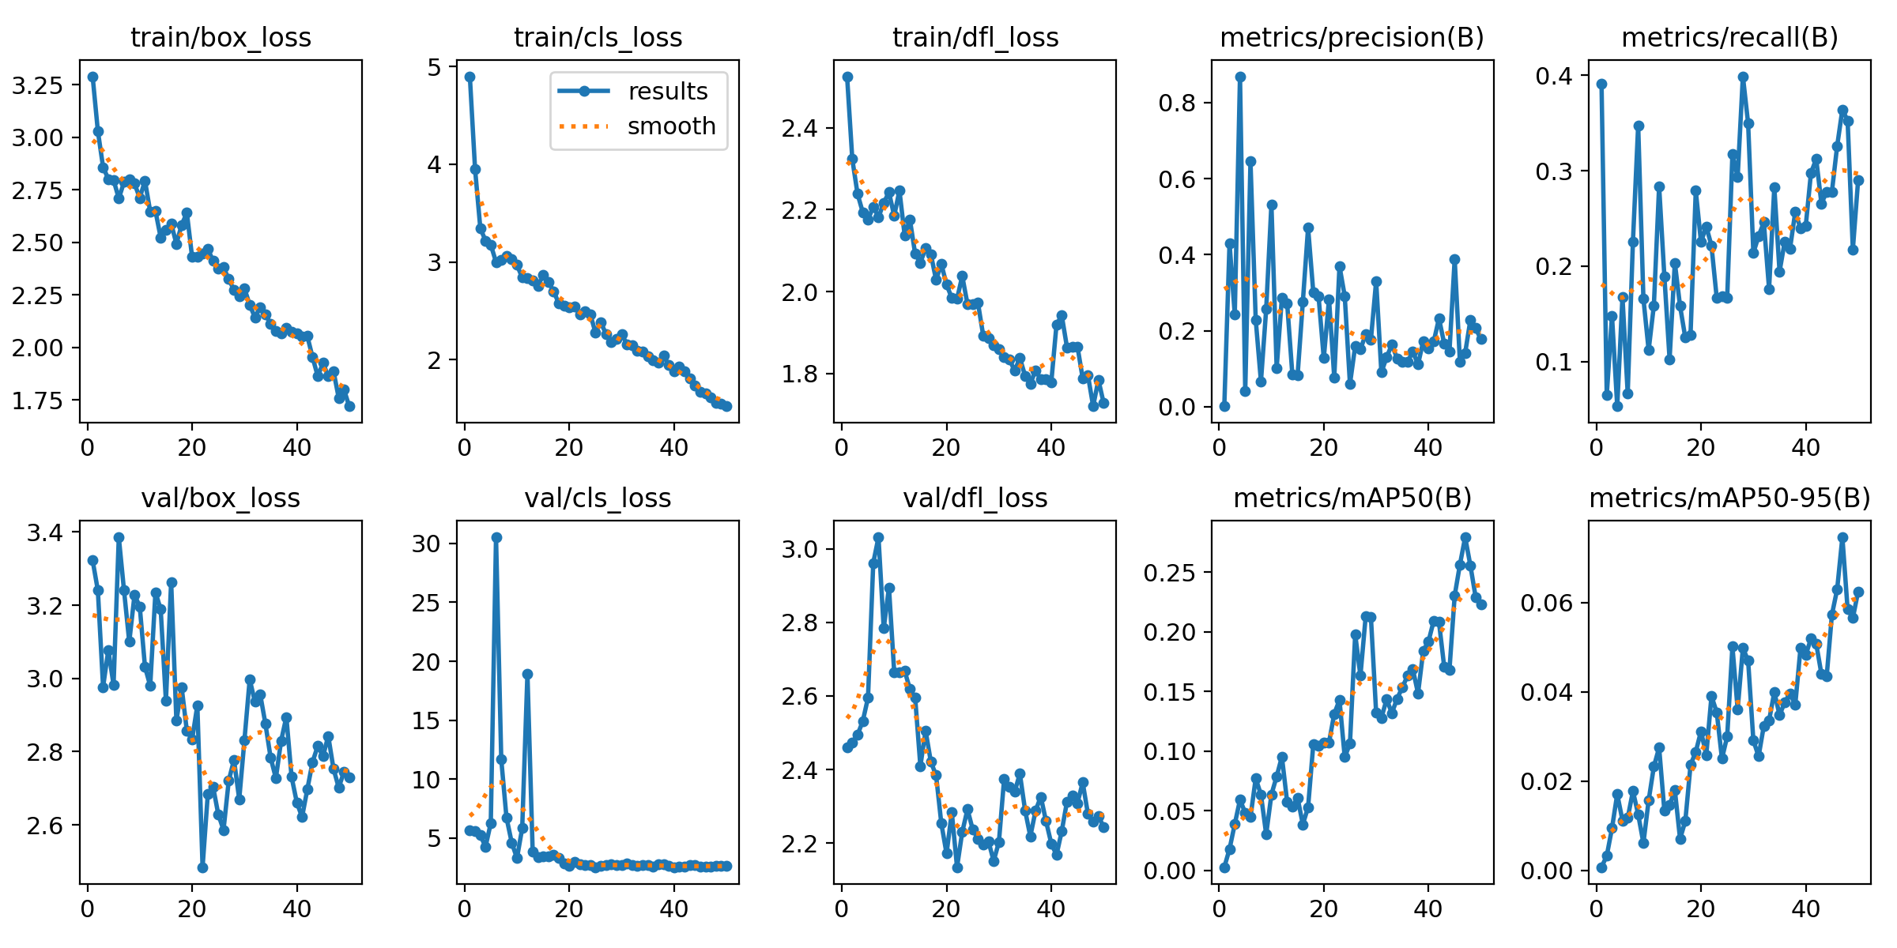

This analysis covers the key training and validation metrics observed during the training of our YOLO-based object detection model. The metrics evaluated include box loss, classification loss, and distribution focal loss (DFL) for both training and validation, as well as performance metrics like precision, recall, mAP@50, and mAP@50-95.

1. **Confusion Matrix**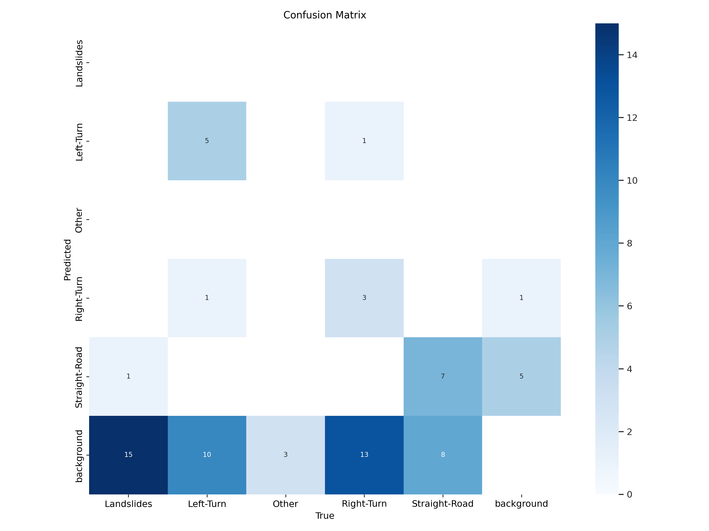

The confusion matrix illustrates the model's performance in classifying different road conditions. The matrix includes five classes: **Landslides**, **Left-Turn**, **Other**, **Right-Turn**, **Straight-Road**, and **Background**.

## Example Visualizations

To assess model performance visually, we ran the trained model on test images. The results showed bounding boxes around detected objects, along with confidence scores and class labels. Confusion matrix visualizations confirmed the model's capacity to correctly classify different road conditions.

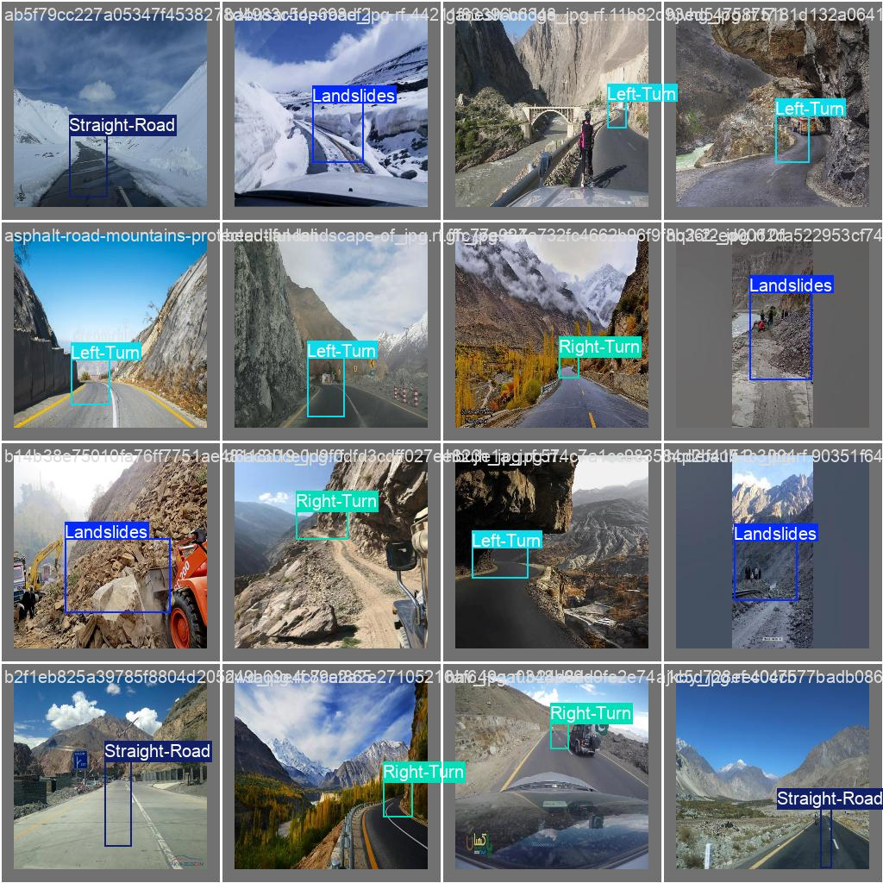

**Conclusion**

Through this project, we successfully developed an object detection model that accurately identifies road conditions and turns using a dataset collected across various regions in Gilgit. The YOLOv8 framework, combined with a pre-trained model, allowed us to achieve high precision in detections. This project provided valuable insights into data collection, labeling, and model training. The experience gained will be instrumental in our future work in machine learning and computer vision.